MERN Stack

# Section 1: What is MERN?

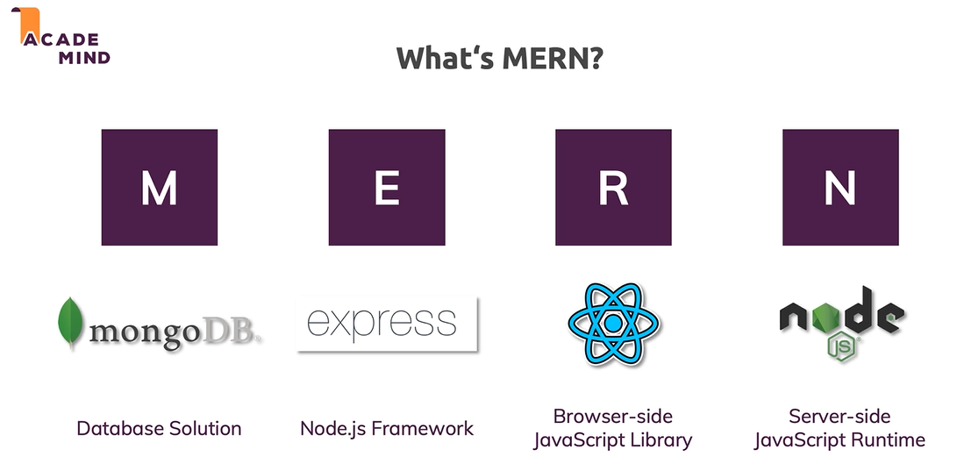

## REACT

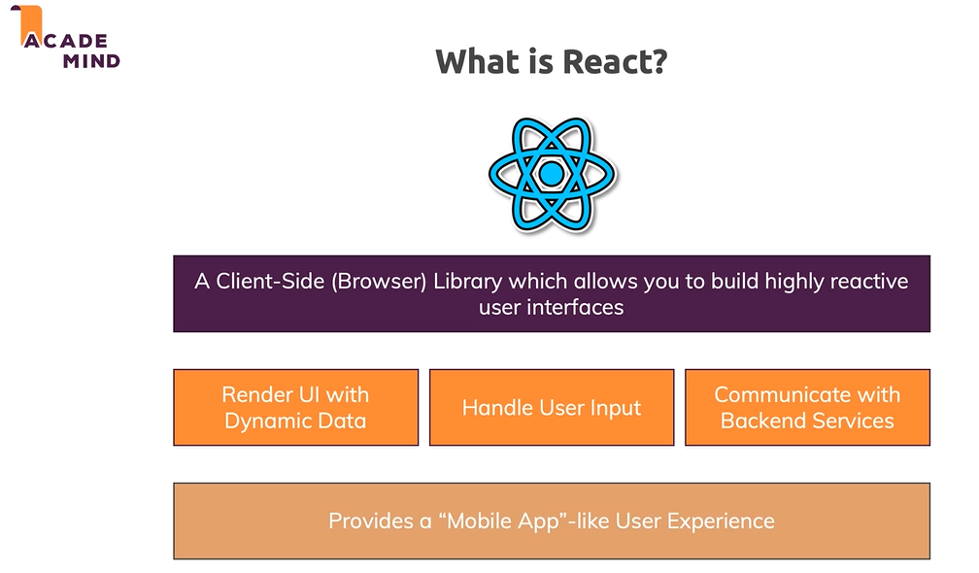

## NODE

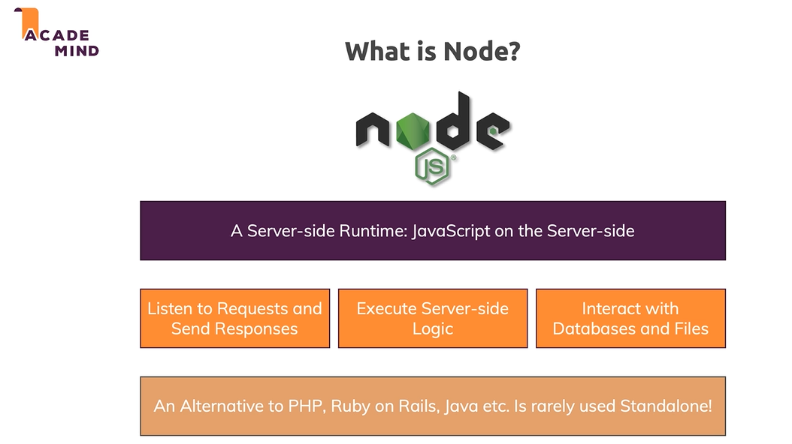

## EXPRESS

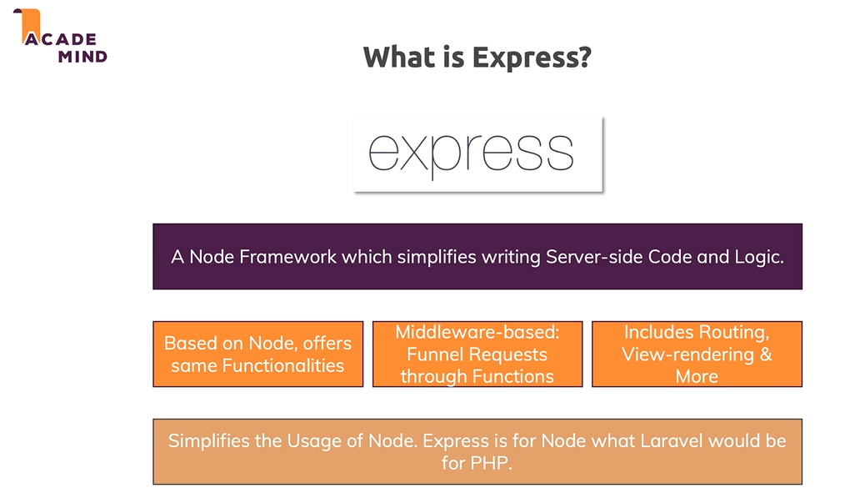

## MONGODB

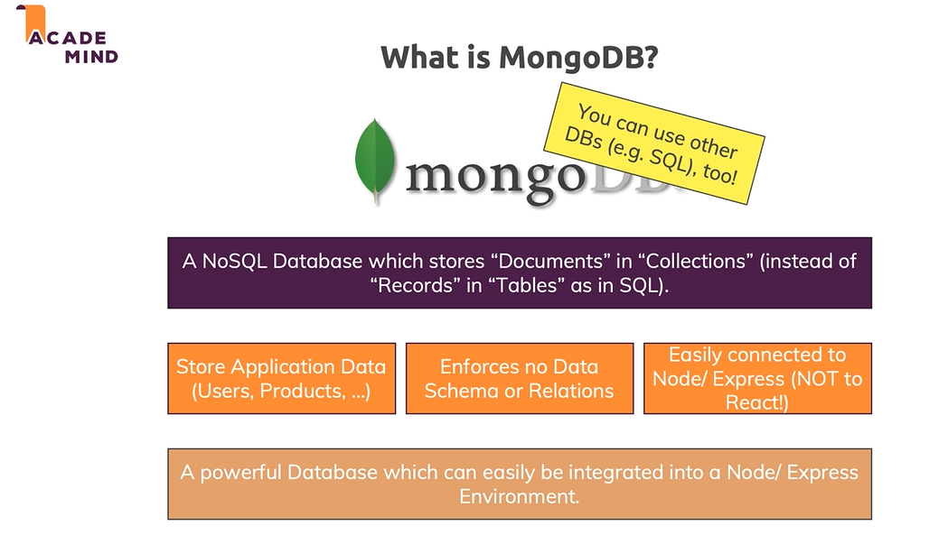

## The Big Picture

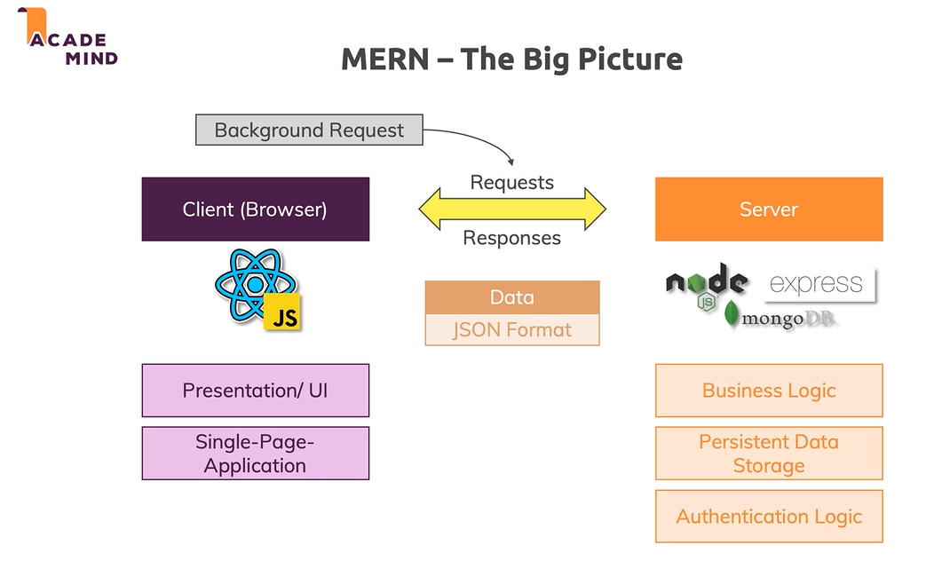

## Course outline

# A diagram of a course Description automatically generated with medium confidenceSection 2: Theory

The server, runs on a machine, that runs with the help of nod js, and a framework in place aka express.

The database server can either be on a different server, or the same server.

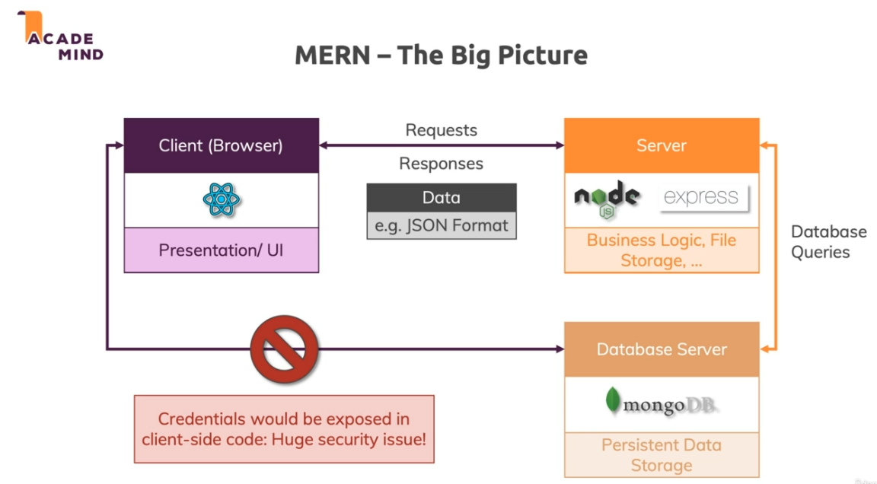

## The Frontend

We will make a SPA (Single page application). Everything is one index.html file.

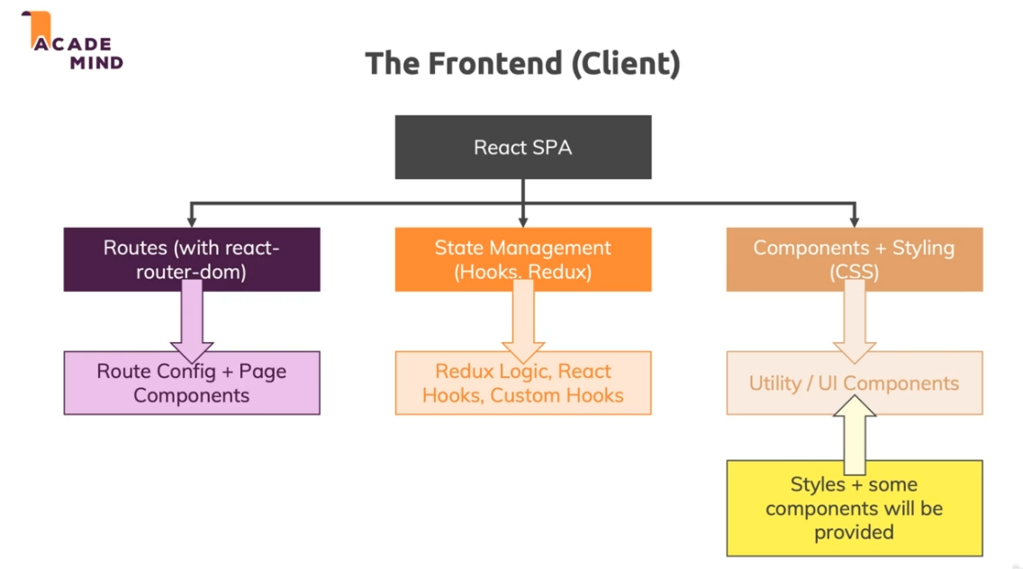

## Backend

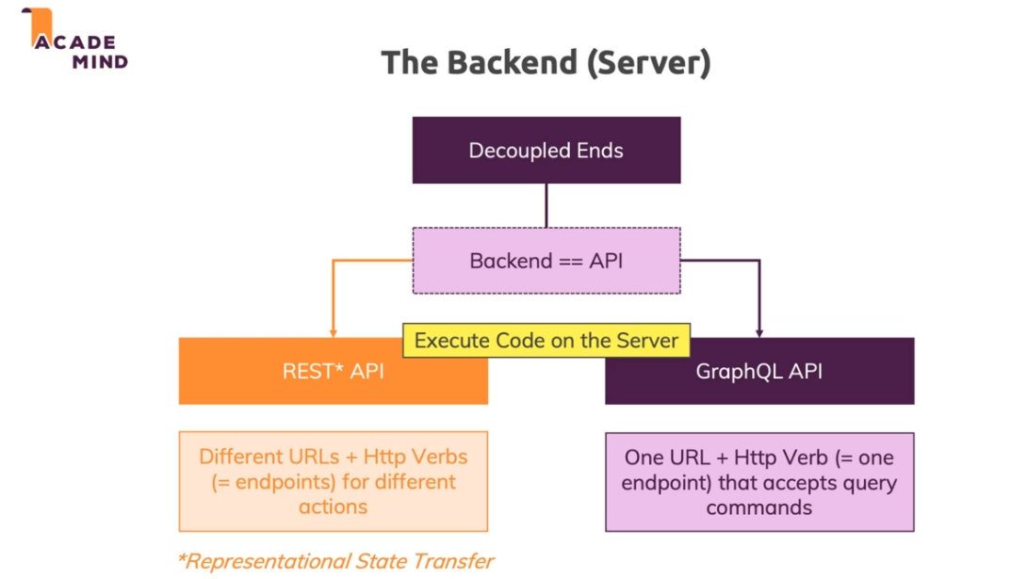

## REST VS GraphQL API

### REST

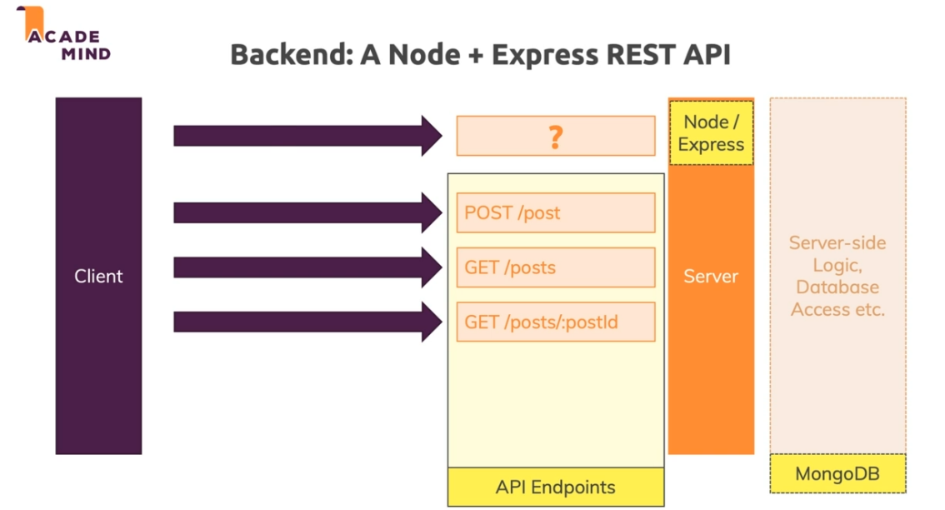

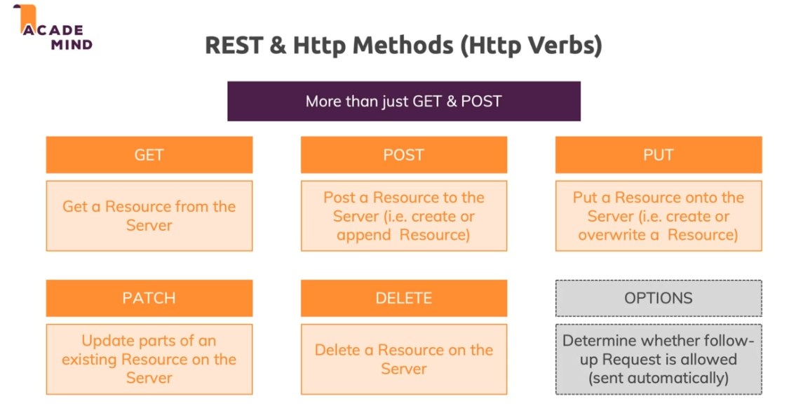

IMPORTANT: its up to YOU, to decide which words in the API do what. You determine the behavior of the API. The verb itself does not determine what happens, its what you specify for the verb to happen that happens

### GraphQL

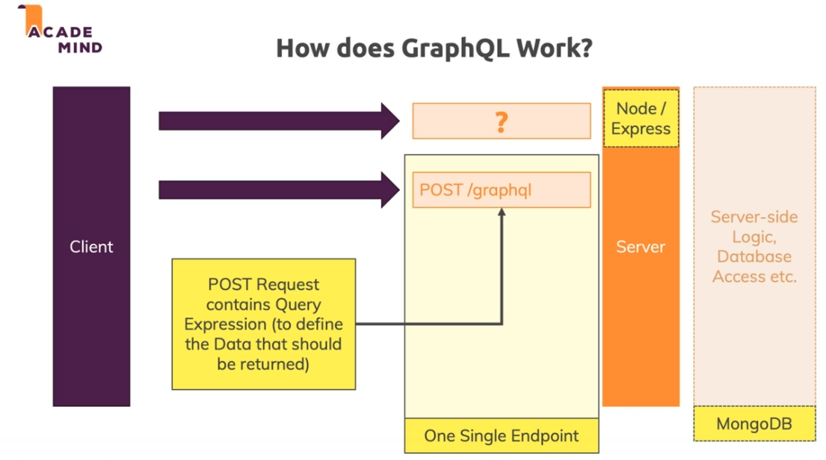

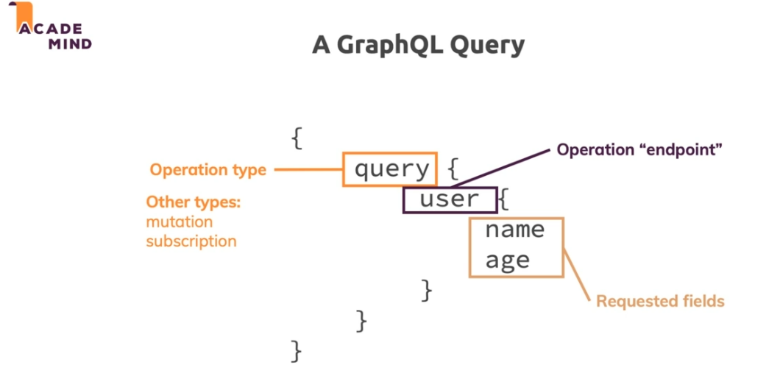

### VS

Rest api is totally separated. You can legit completely swap the front end entirely since its separate, and the api will still work the same way

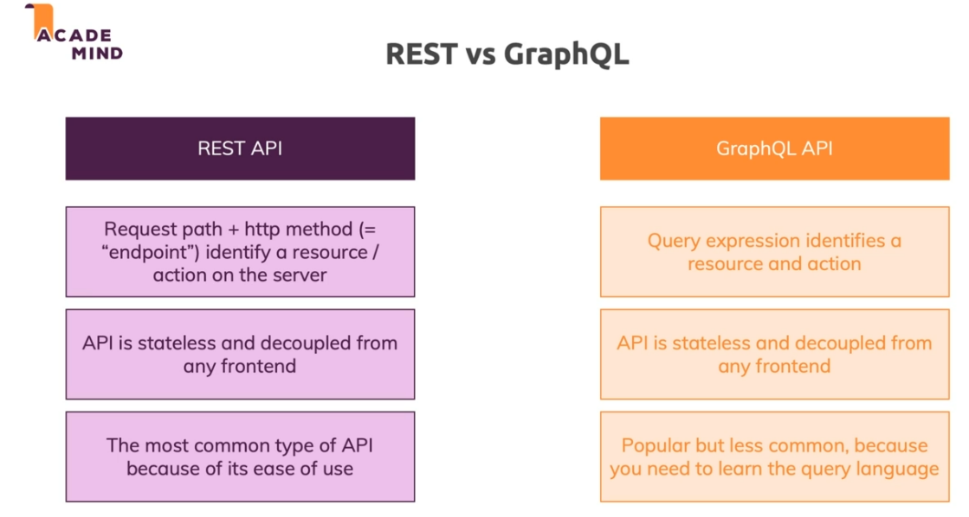

If you want to be able to right a GraphQL API, can watch a free example in section 12 resources,

## Connecting Node and React

We can use 1 server that hold both the react app as well as the Node running to handle the requests. We could also separate into two servers. The db, is often good practice to have on another server, such that the queries themselves don’t slow down your app and its performance.

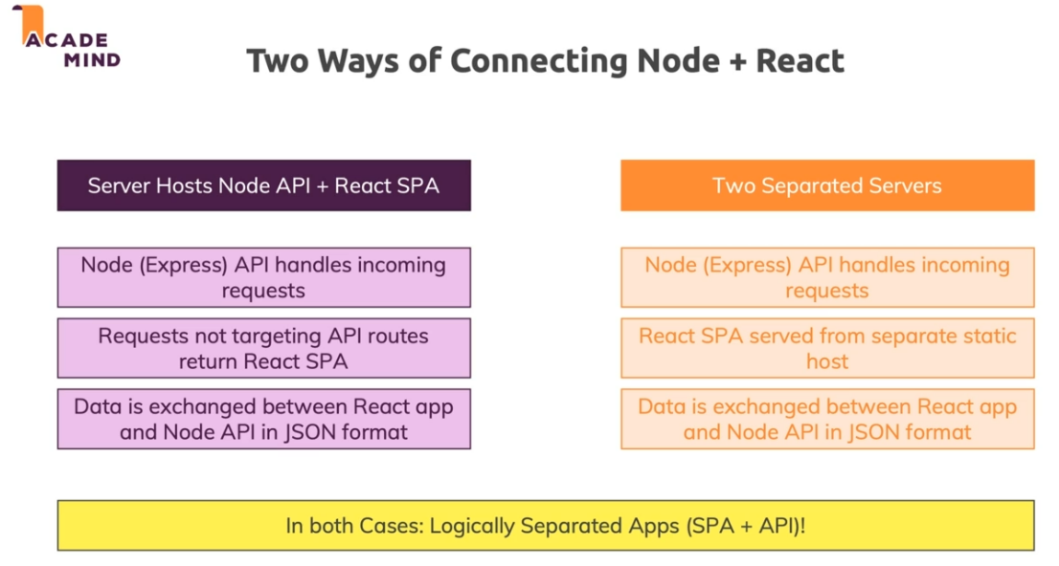

A third way but not really good/reactive way:

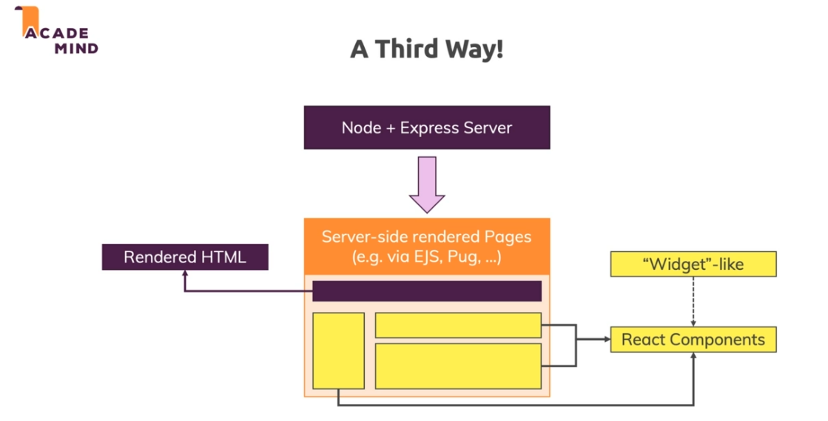

Question:

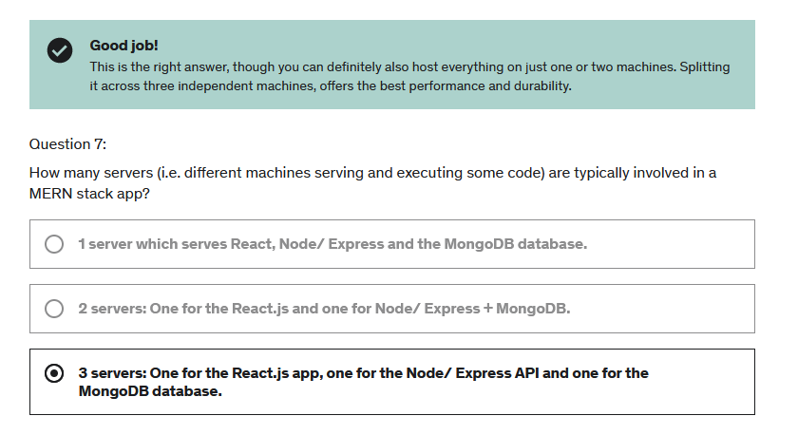

# Section 3: Planning a MERN APP

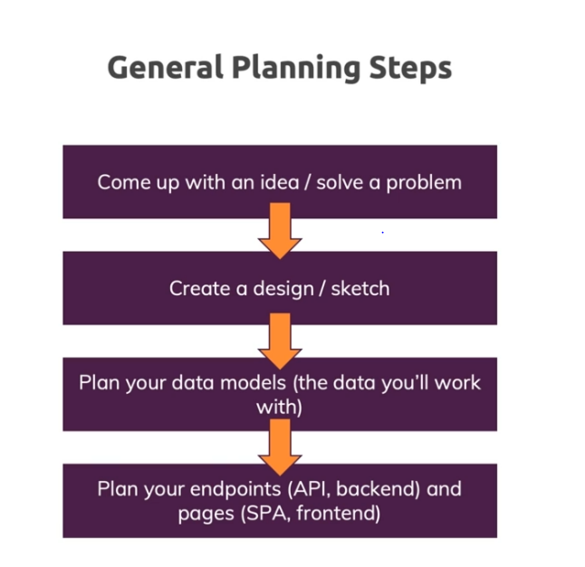

## The idea

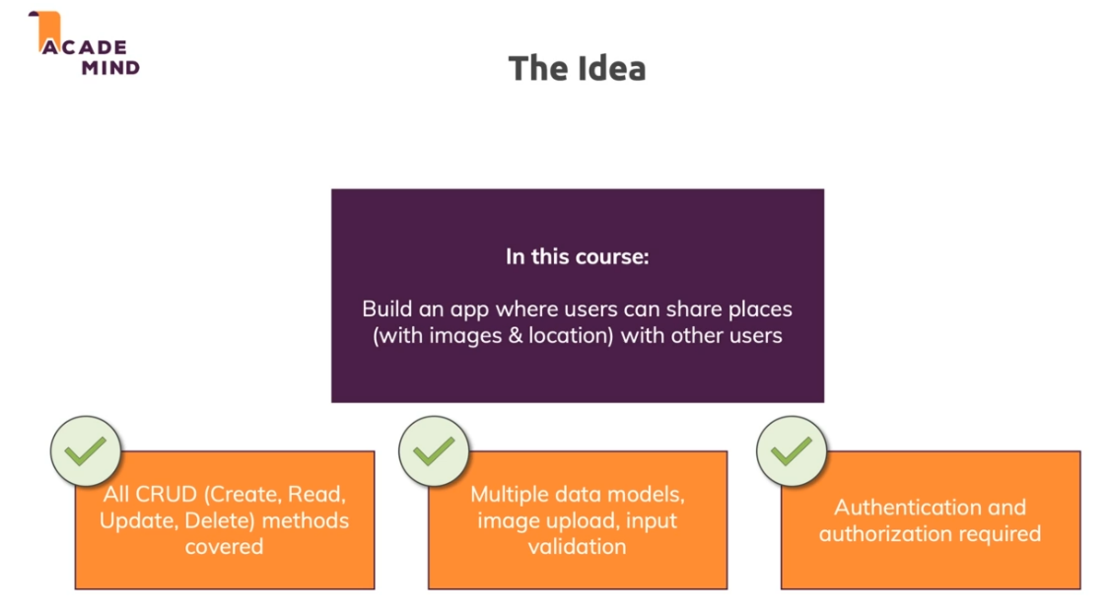

Sketch the front end, plan the data + api endpoints used, and then the required SPA pages

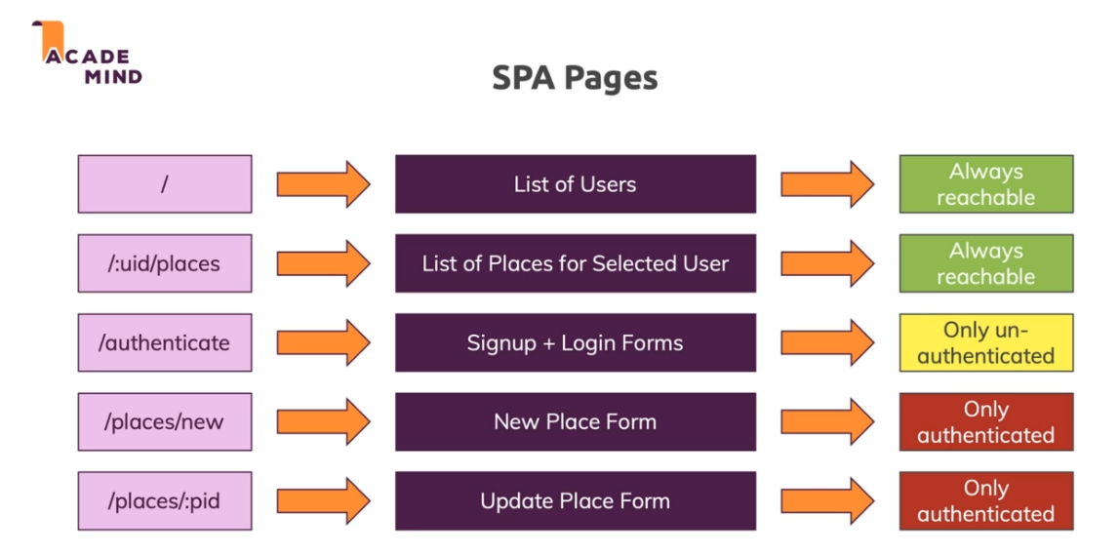

# Section 4: React refresher

## JSX

Recall what jsx is under the hood:

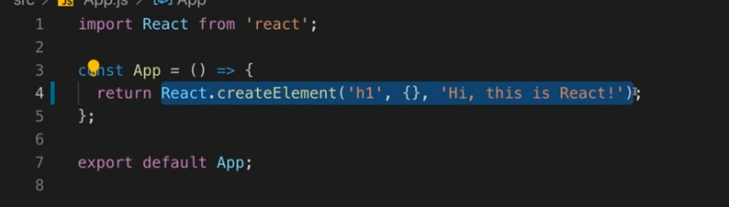

Is actually the exact same thing as this:

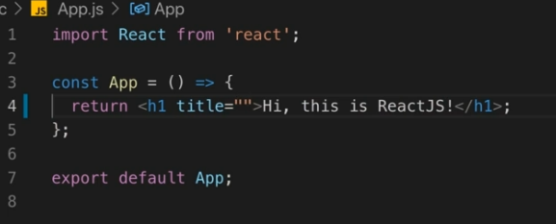

## Rendering lists of data

A reminder that when you map an array of data to jsx elements, you need a id/key:

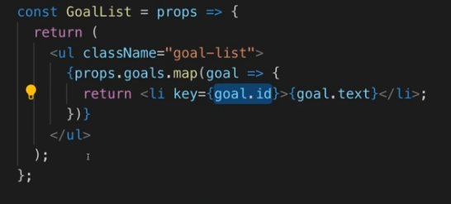

## State bullet proof approach

If you have state updating and your worried about the state taking time to actually update the lvie values, say you press the submit button multiple times, can do this:

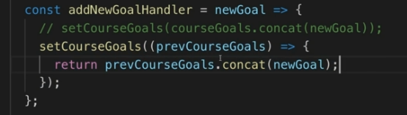

# Section 5: Building the UI

## Starting pages/routes

This old course uses “BrowserRouter”. You cant use loaders and the special apis from createBrowserRouter

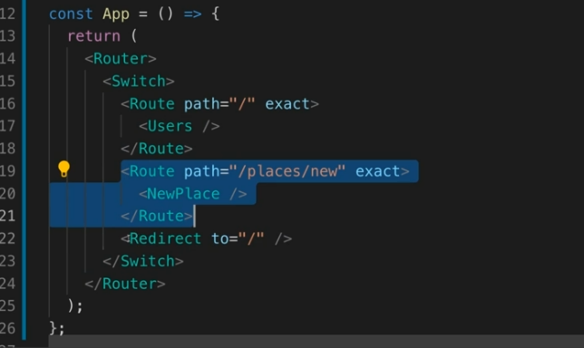

# Section 6: Node + Express Refresher

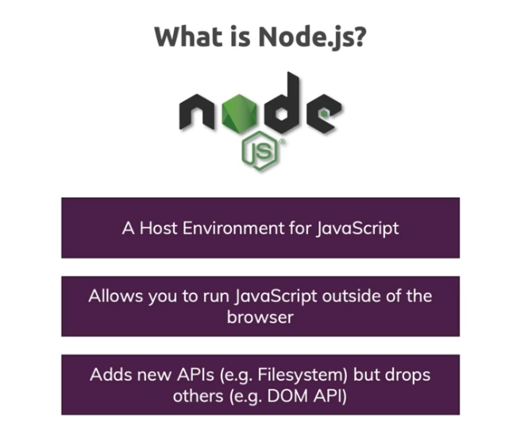

## NODE.js

### Executing JS code with Node

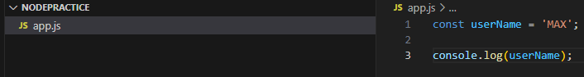

Then execute:

node app.js

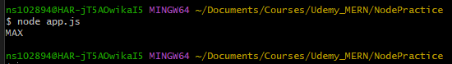

### Built in NODE functions

Understand that nodejs is not executed in the browser. Therefore, browser based apis/functions that are normally run in the browser will not work when executed with node. But, we do get several built in functions exclusive to NODE and that cannot be executed in the browser, such as being able to access filesystem. For example, the require() function. This is a global function always usable in NODE. No imports required or anything like that. Can use it to grab Node modules

### File System Operations

We use a NODE module called ‘fs’. In the file we want to use it, use a require like this:

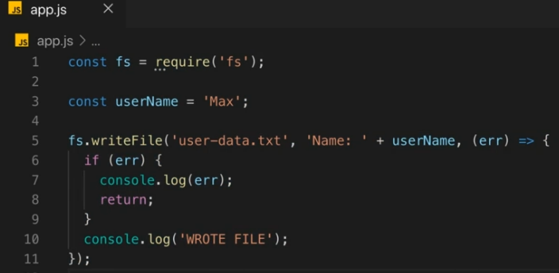

The writeFile() method, takes a input file, the content of the file, and then a callback function that executes once the writing has been completed. Writing is not instantaneous, therefore writeFile is Async, and will allow NODE to continue executing code without having to wait for the write to complete.

### Sending Requests and Responses

Use require(‘http’) to return a usable http object , and then use the createServer method in this object. Use the server.listen(5000) method to have the server listen to a port. The listen will fire up a server that will continue to run on your host machine listening to requests on the machine. By default of course we are not exposed to the internet. What important is this server will not shut down unless we tell it too.

Create server takes in a function argument, where the function params are “req” and “res”. In this function, it is executed soon as a req is received, and then we can read the req object to do whatever we wish. For browser requests its important to ensure that we also return a response, otherwise the browser is left waiting and will eventually timeout and get nothing back.

res.end(‘Some TEXT’) means that we are done, and we send a response back. It can take some input like a string as part of the response returned back

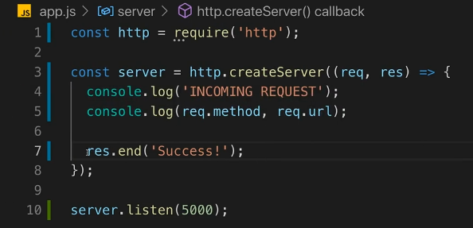

Run node app.js, connect to localhost:5000 in our browser, and it works:

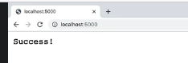

Can specify content type as well:

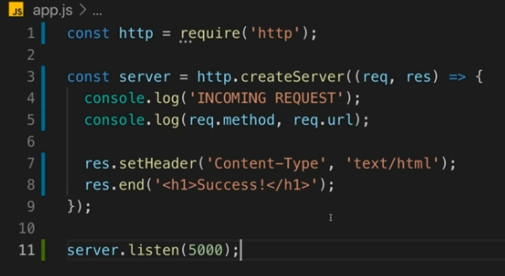

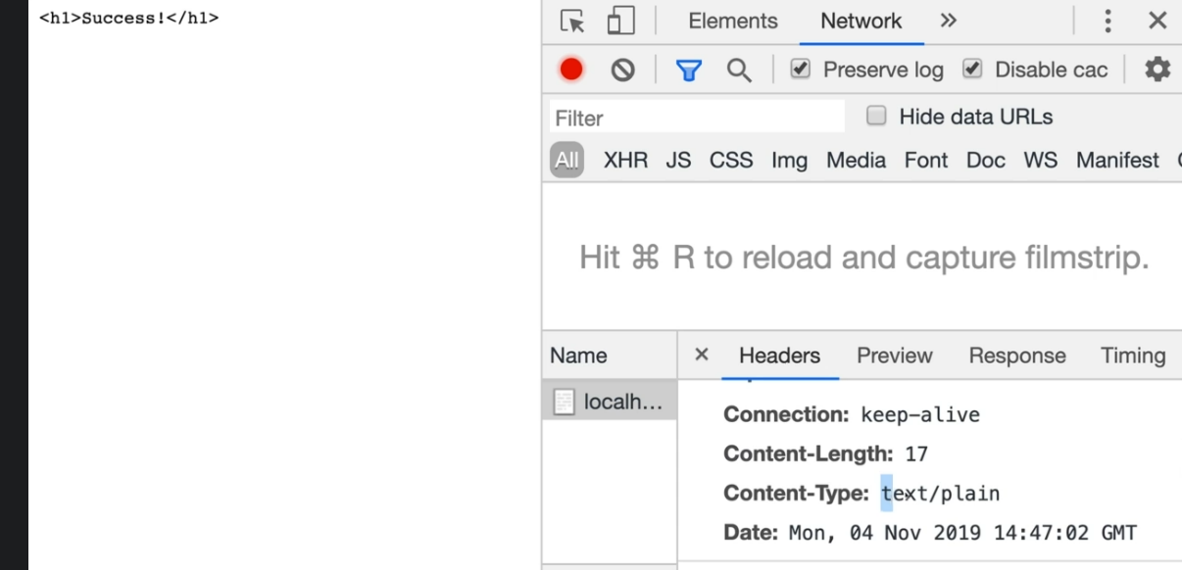

### Code without Express (ugly)

Lets say using what we learned above, we return a form with a submit button, and then we want to display the text the users enters upon submit. The code would be like this:

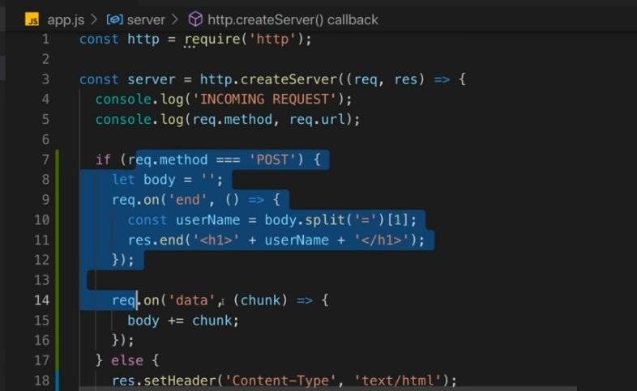

+



Yikes! We need some sort of framework/structure in place to make this cleaner. While its possible to make an app like this, it is very much not ideal and a lot of extra work.

## Express.js

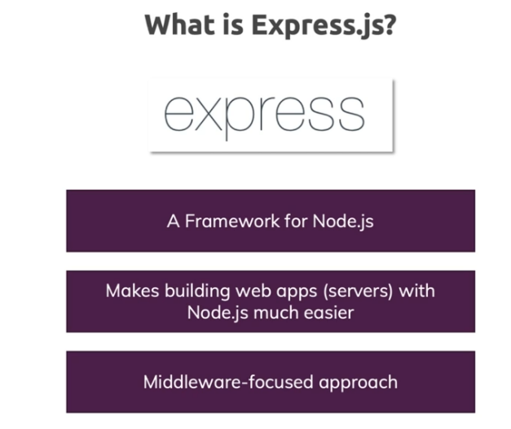

### Adding Express

Express is a library, used for Node.js

npm init

Hit enter bunch of times for default.

npm init will create a package.json file, which is a file that contains all the dependencies we want to install. We are creating a “managed project.” It looks like this default:

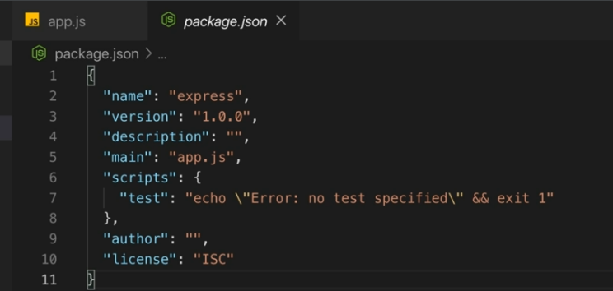

Then install express with npm:



The install, will create a package-lock file, and then install a folder node_modules folder, which contains express, dependencies, everything you installed. It will also add object param “dependencies” in the package.json file

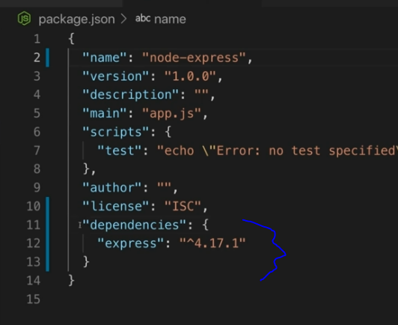 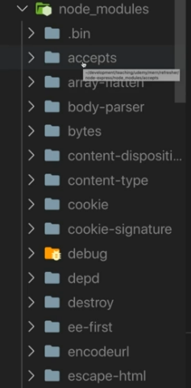

Its good practice when sharing code, to delete the nodemodules folder

### Using Express raw

In your file, do a require(‘express’). This is a function. Calling the express() function will return an app object. If you do a listen(), express will automatically call the createServer under the hood.

Express has a core philosophy, in that all incoming requests, must first go through a funnel of middleware functions.

To define one of these middleware functions, we have the use() method (use works on all incoming requests). This method will take in an function, with a req + res parameters passed in it, and a next parameter (this is a function actually). You call this next() method, when we want to move to the next middleware in line. You should always call the next() method at the end of every middleware function if we want to move to the next middleware, otherwise we wont be able to reach all the middleware functions. Next() should only not be called, when we are actually in the middleware we want to execute.

You can send back a response like this:

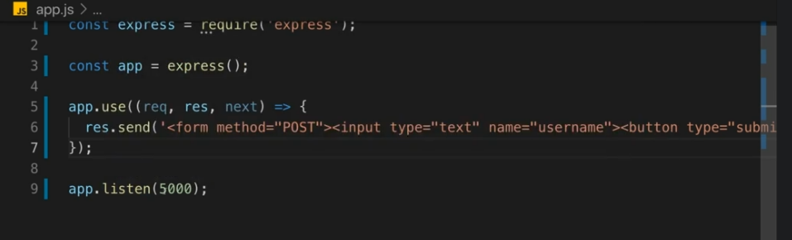

Not great of course, but this is one way.

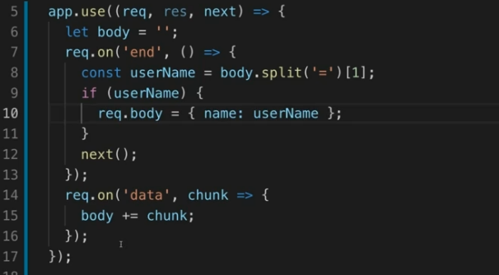

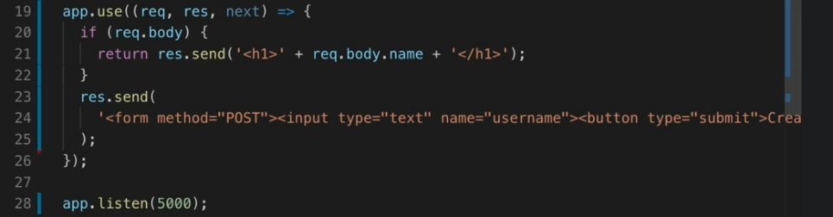

Still not great. How do we use express?

### Create a dev server

Using node to constantly restart our server whenever we make a change is very irritating. So, lets improve this by installing nodemon:

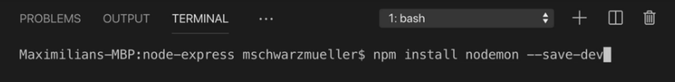

Then, add a start script inside package.json scripts.

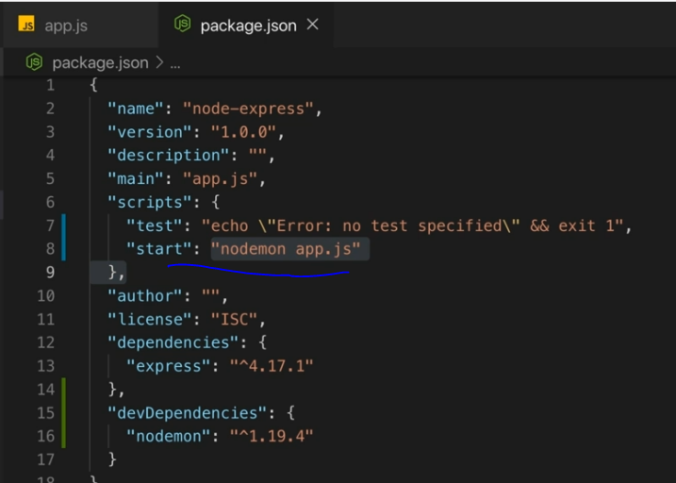

For test and start, you can just go npm start . Don’t need to go npm run start.

Now, the server will auto restart when you make a change.

### Cleaner express

Run npm install body-parser. This give us ready to go middlewares which we can use in our express apps.

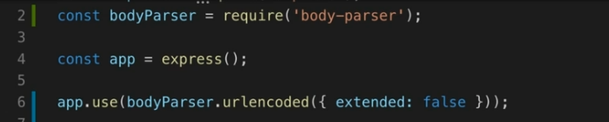

We can use this now to help us with our get/post requests. The get/post, unlike “use”, need a path specified. The path in get/post must be an exact match, unlike “use”. Give out form button an action for /user ,

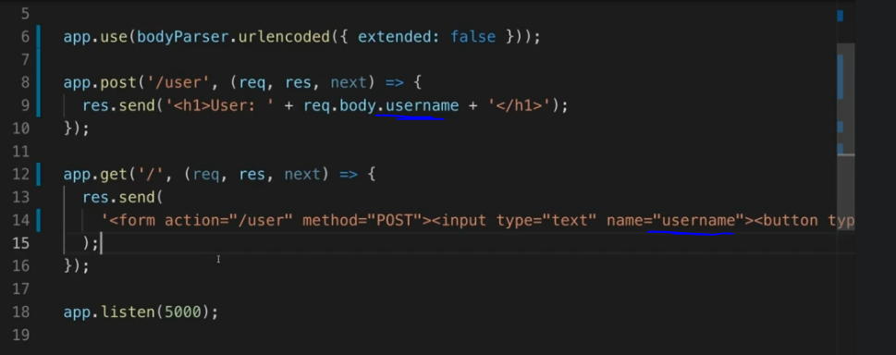

With this, first a form is generated with a button and text field, and after entering text in the field and submitting, we get the text displayed in a <h1>. Note how we didn’t need to parse the body or anything, it was much easier this time around

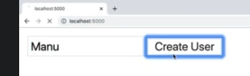

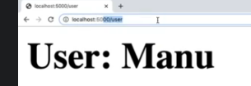

### How does the code execute

When the server is started, and we run our app.js for example, what happens? Well of course node will parse the entire app.js first and execute it. What is not executed right away though, is the middleware functions. So, javascript would register the middleware methods, store a reference in memory to them, but only executes them once they are called. That logic under the hood is what express and node together are doing behind the scenes

# Section 7 Writing the REST API:

Ahead of time, we have already planned our endpoints. Its worth looking at the section 7 final code to see everything in use. npm install, then node app.js

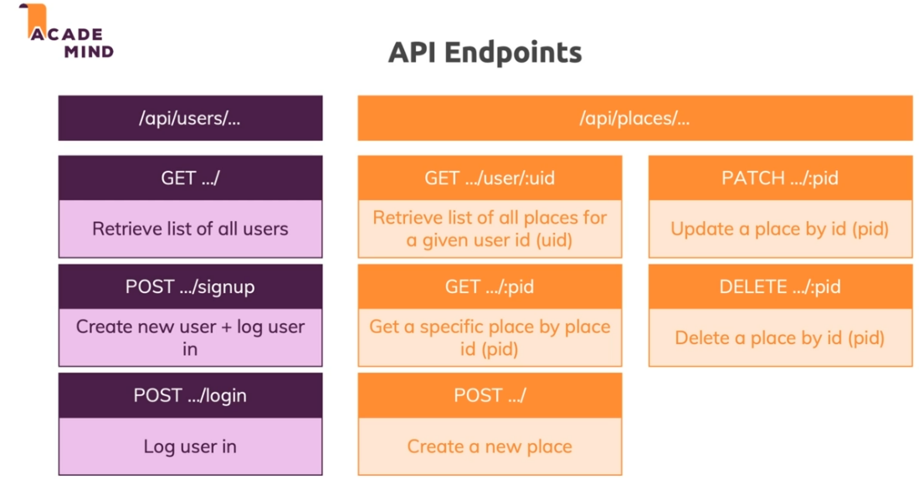

## Adding basic routing

Now, when writing apis, its good practice to have all the middleware spread out and not just in 1 single app.js file. Common convention is to create a “routes” folder in your project

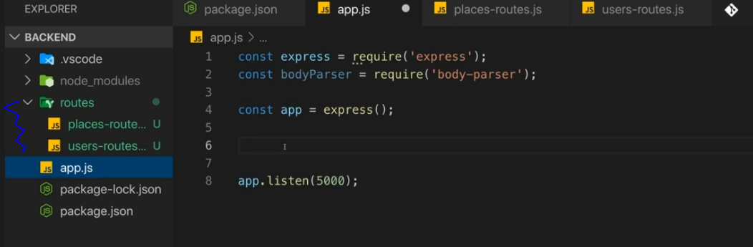

Then, in your separate middleware files, create routers, instead of actually executing express() like you do in your main app.js. These routers, can be exported, and then imported into app.js allowing for cleaner code.

In these middleware files, go ahead and specify all the route logics in the same way, with “use”, “post”, “get”, etc….

Recall with MERN we are going to send data back and forth in JSON format, for this, we can use on the response object the json() method, which will take nearly any argument (object, int, string, array, etc…) and then convert it into json, which is then automatically sent back with calling the method.

Exporting:

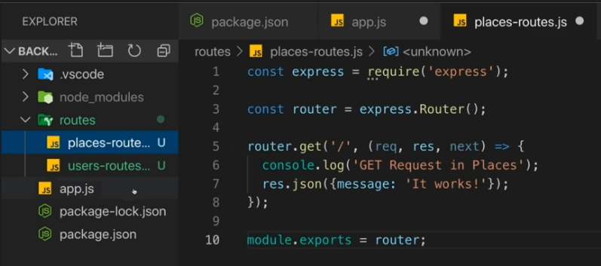

Importing inside app.js:

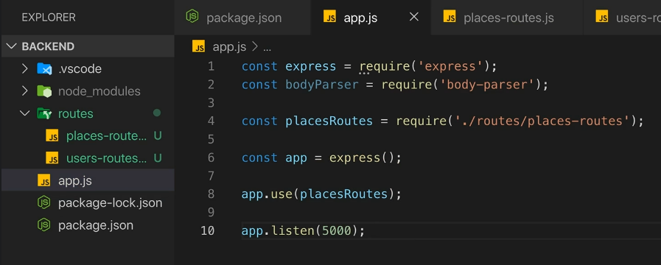

## Adding Place specific routes

We want to hit our API url path endpoints. So in our app.js, we can specify the specific api endpoints. Recall with “use”, the paths are NOT EXACT, only starting. 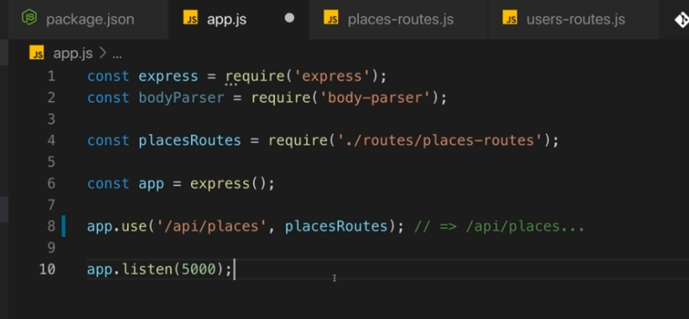

Then, in the actual middleware files, the paths are continued in the next files.

Lets say we want to grab data location/place data. In our places-routes.js file, we have a dynmically appended path for place id (using “:” in the path), and then some dummy json saved locally in the same file with sample data (just for testing. In reality, this would be replaced and filled with actual data fetched from db). The “req” object, comes with a .params which can be used to access the dynamic url/key enerted in the request. See two screenshots below:

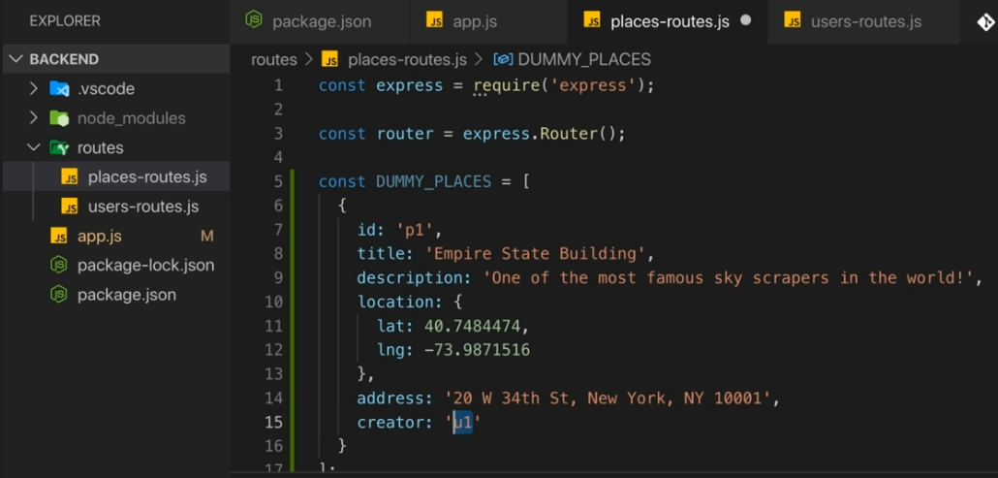

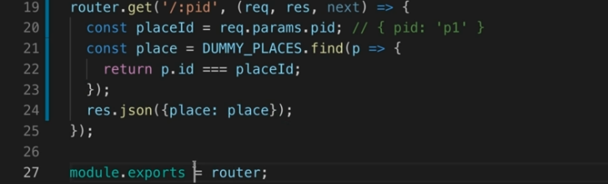

Alt js syntax: 

## Error Handling with Express

The res param, has a status() method which you can use to change the status code of the response. By default the code is 200 (success), but you can change this to 404 for example (data not found), and then execute json() to send.

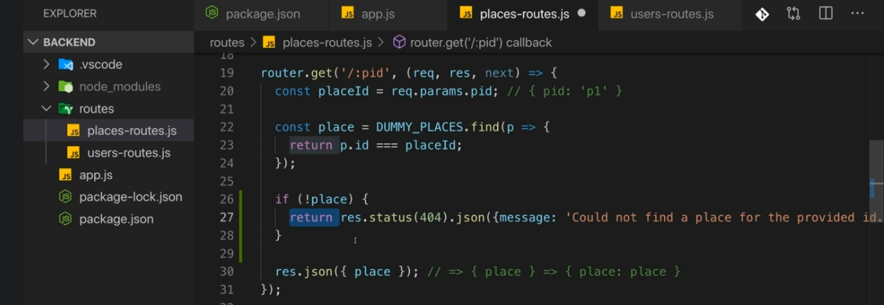

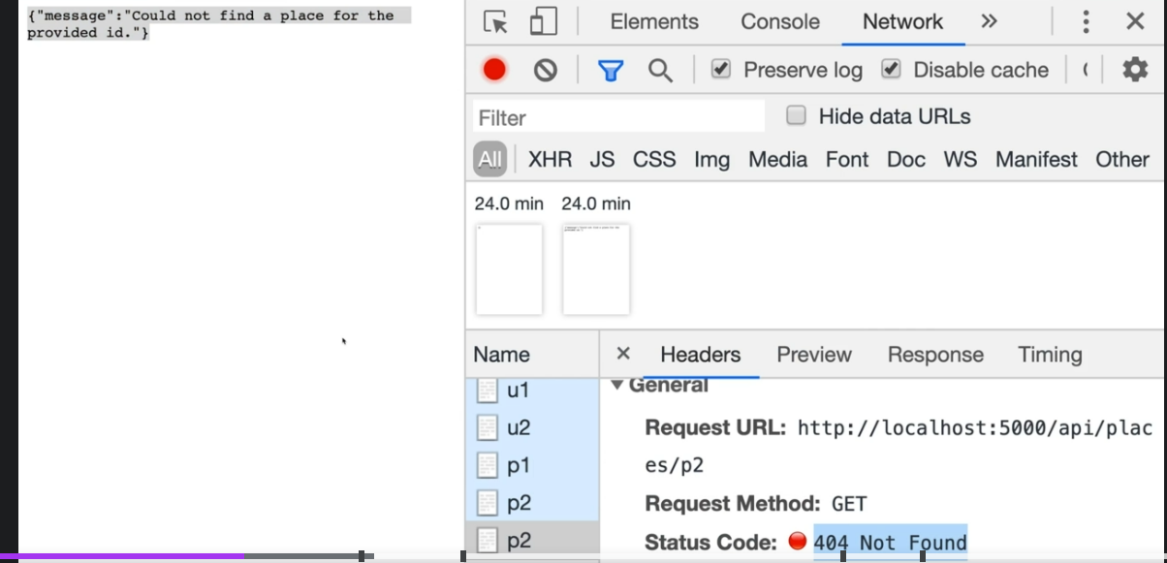

This is ok, but this could lead to lots of repetitive code. Express has a solution. Middleware functions with 4 parameters, are actually treated as error MiddleWare. Keep it in the app.js your central express file. Here, we specify what to do. The snippet below if we have an error code we return the code otherwise default to 500. Also set a default message if there isn’t already one set.

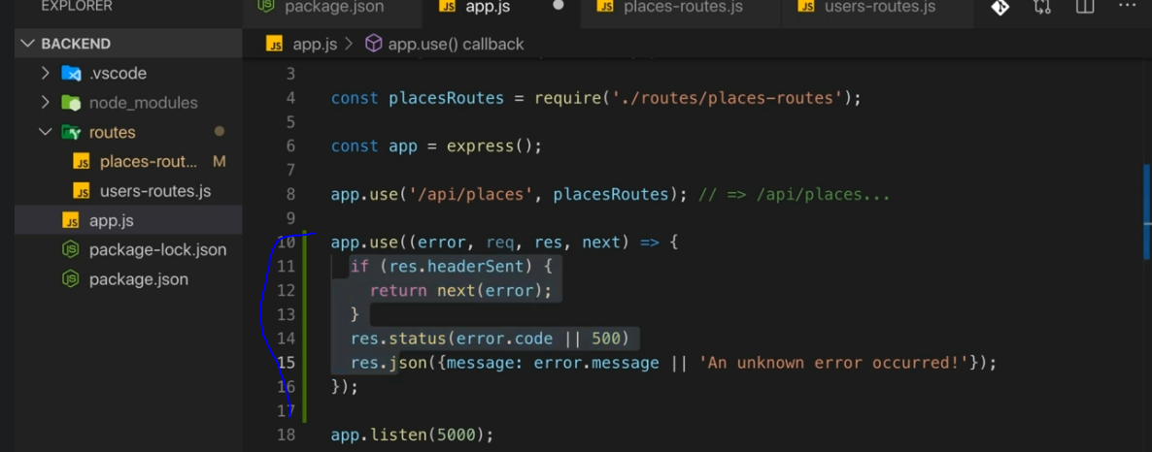

So in the middleware file with this, if we cant find a place, we set the error code/message and then throw the error.

Sync case: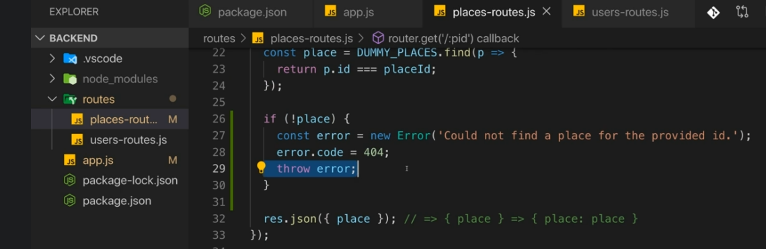

Note, that “throw” will stop the executing of the code which is what we want. We don’t want to accidentally send back 2 responses or we get a problem.

Another note, this works because we are performing a syncronous middleware, because we are just getting local dummy data. In real life, its likely this is async because we are first getting data from a database. In such a case, you want to modify the code above slightly, and simply call a next()

Asyn case:

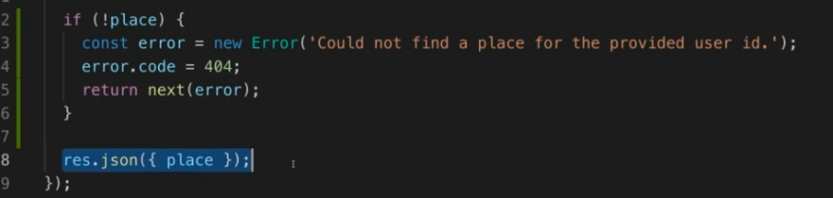

But still, there is code duplication. Can we do better? Make an **Error Model!**

## Adding a Error Model

A model, is a blueprint/definition for a data object we work with.

Lets create a “models” folder in our project, and there create an HttpError class, which is just a custom class that extends the “Error” class.

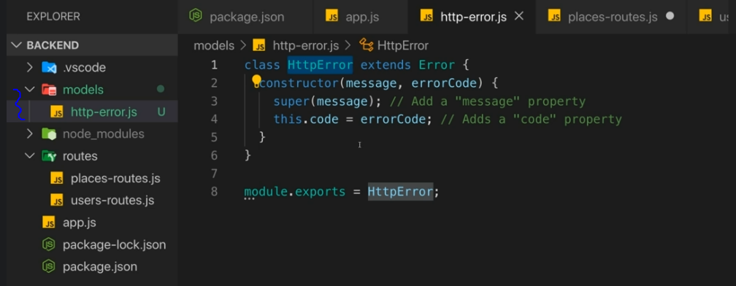

Import it:

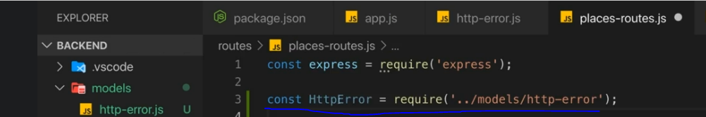

Now we can just throw our error like this, since our custom HttpError is a valid Error class extension.

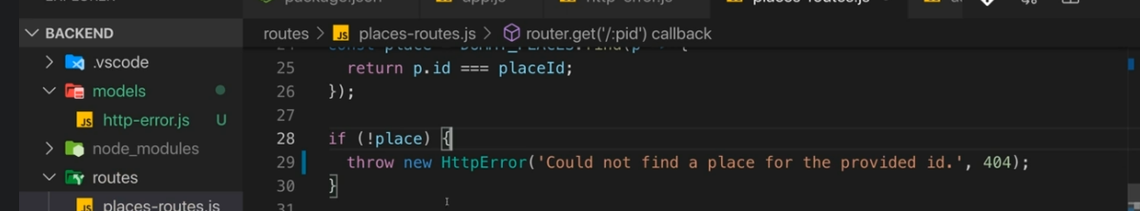

## Adding a Controller

Note that middleware files could potentially get big. Therefore, the MVC approach is ideal. Controllers hold the logic that execute when a request is reached. So in the middleware/routes files, you keep the url logic, but then move the actual logic that’s executed inside a controller function. This lets you see all the routes at once and gives the file a more general purpose.

**New routes file importing the controller:**

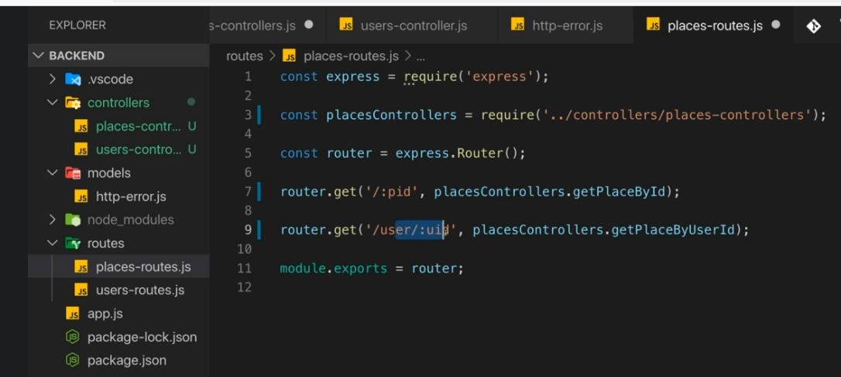

**Controller with the exported logic:**

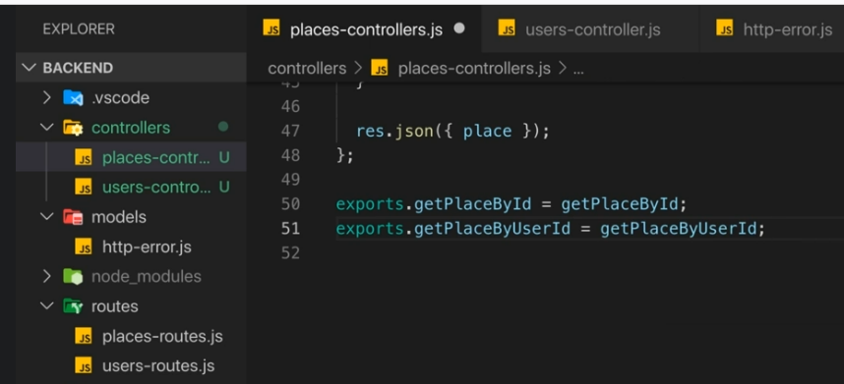

## Grabbing data from a post request

Its easy to grab data using req.params. But how do we extract data from a body again? Because a post request, comes with a request body body, where a get does not. And the data is encoded.

To get the data, use the body-parser package. You want to parse the body first inside your app.js, fist before anything else. Use .json(). Next will be called automatically with this recall.

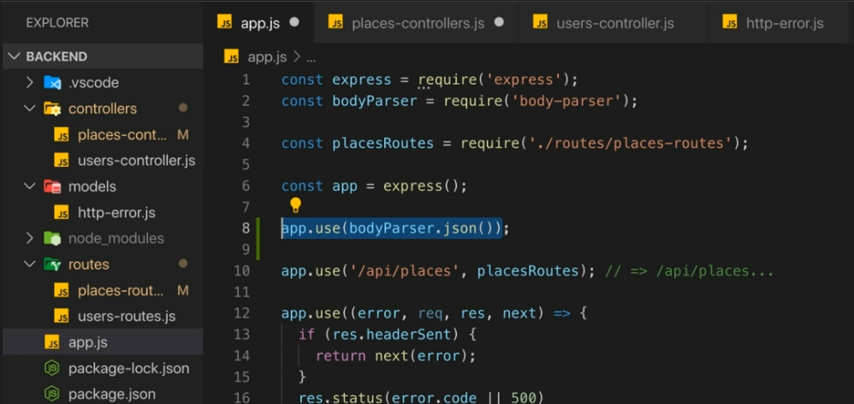

Can then grab the data inside the controller like this, and push it to dummy array, and send the success response back (id will be shown later):

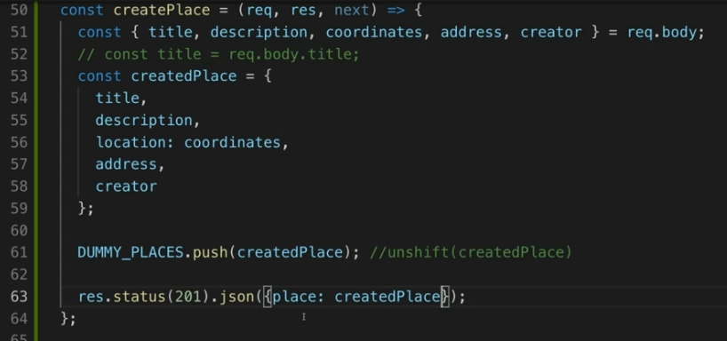

**Good tip: if you want to test the post request, you can’t just enter the url in the browser. By default, whenever you pass a url in the browser, its always going to be a get request. Therefore, you can use a tool like postman to test your apis, where you can create your request body.**

**Example:**

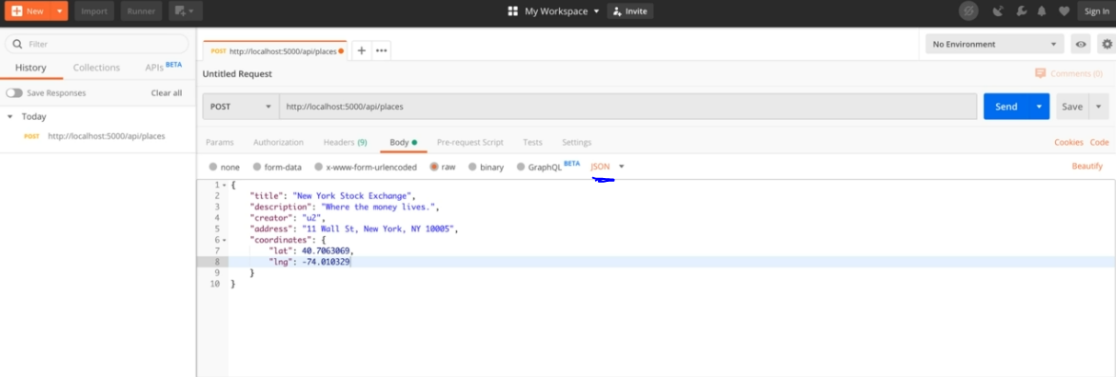

## Generating unique ids

Can use a third party package

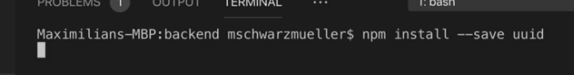

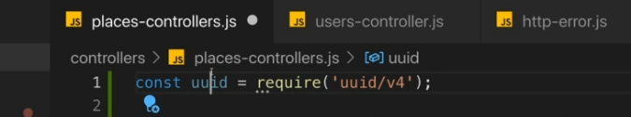

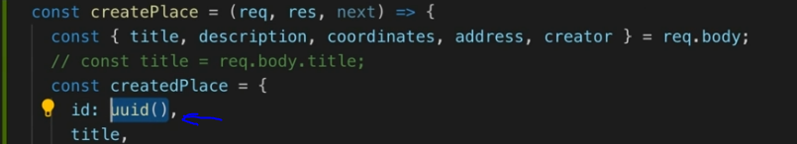

## Handling Errors for unsupported routes

We defined an error model earlier, but this was for specific routes. What about in general when a bad route is passed? By default, an error like this is sent:

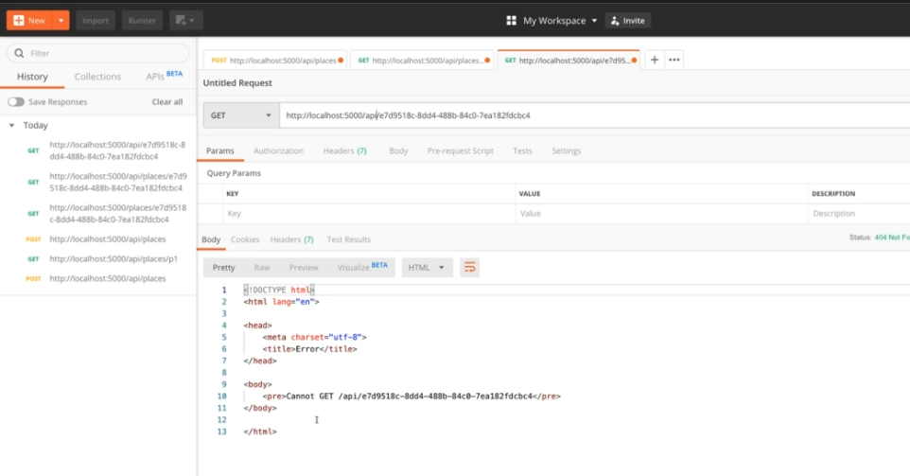

This is not ideal though. We want something nicer/customized. For this, go in our app.js central express file, and then create a generic “use” (this should be at the bottom, which is reached after all the other routes have been passed). And so if this route is reached, we know we have an error as all other routes have been passed an no response has been sent yet.

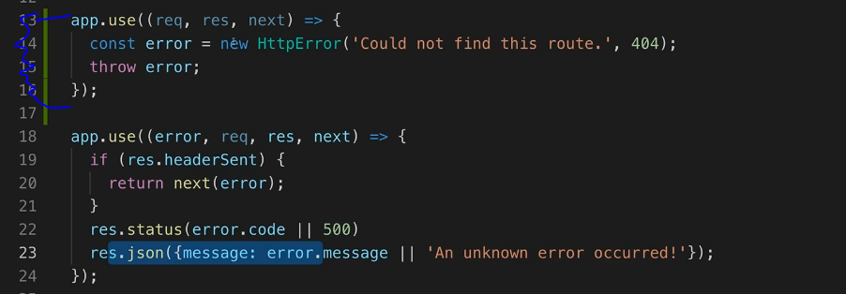

## Patch Requests

Patch requests also have a body.



So we have a pid being passed in the url, and then also the request body being sent. Pretty standard. You can of course grab the pid using req.params.id, and then define what you want to grab from the request body like we did with post. Its good practice, to update the entire object you are storing. Because what if parts fail to get updated, and only some parts get updated? We have a data corruption issue. So, make a object copy, and update it, and then only after assign to the copy.

Seeing it in action:

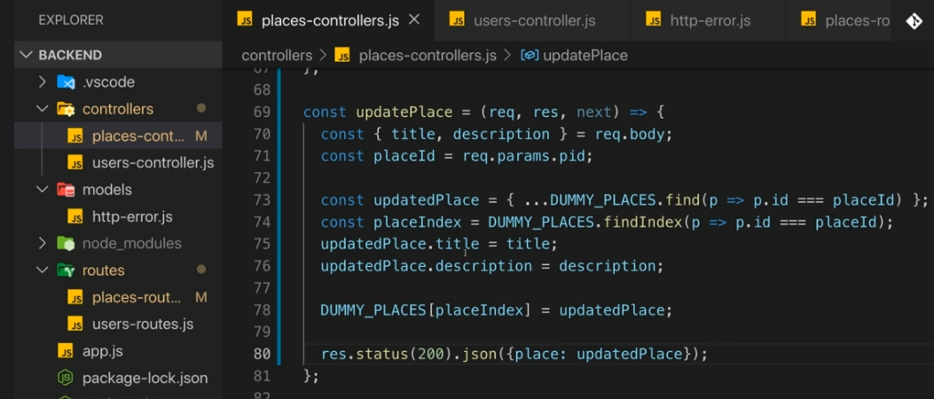

## Delete Requests

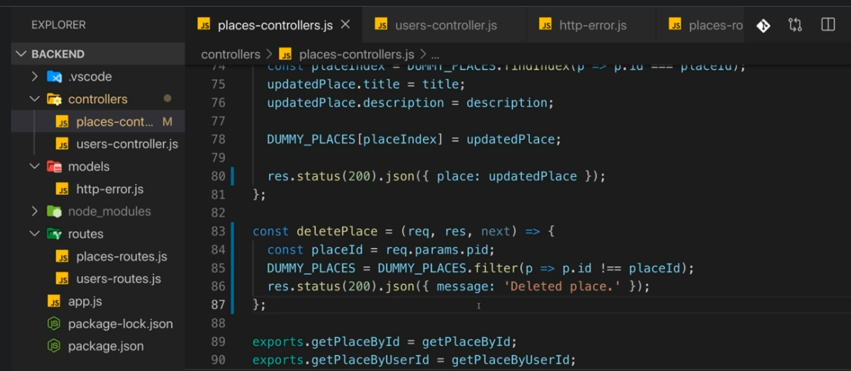

Can test by sending a delete request with postman

## Validating API INPUT

While we can do a lot of manual validation with if checks, this is a lot of work. Use a popular library to save time. express-validator

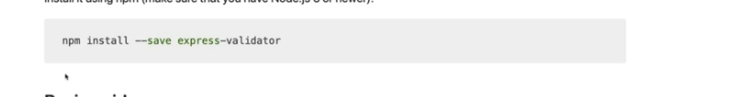

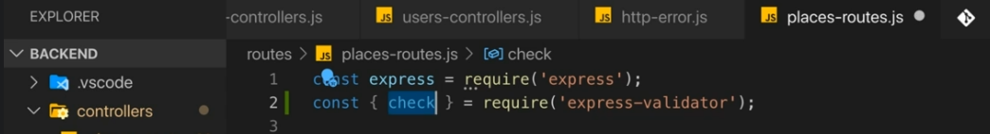

We then add the check as a middleware. Note, you can have multiple middlewares defines per route,, so just set the checks first. Do it like this:

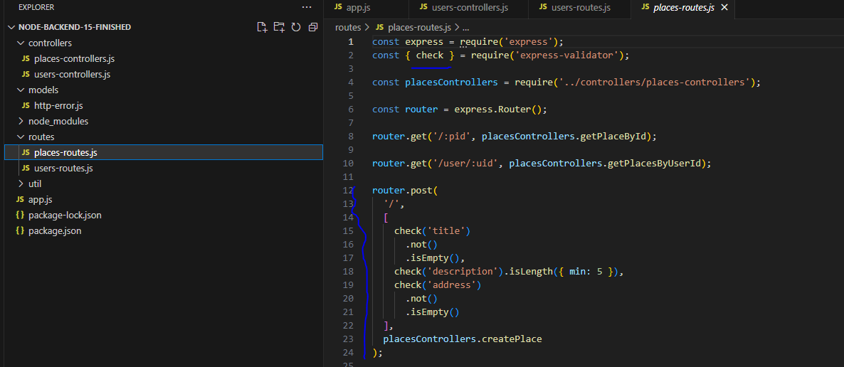

Then, we need to say what to do if error is caught. In your controller, use “validationResult()” in the middleware function executed. We look in the req object, and look for validation errors

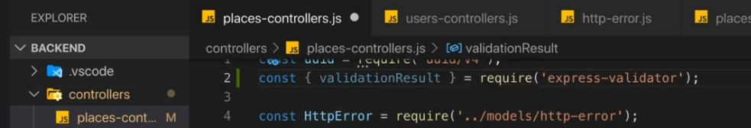

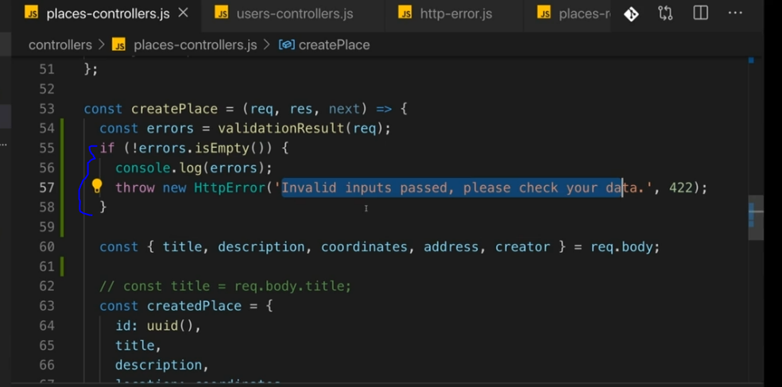

## Send a request from node to other server

Use the “axios” package. Very popular for snding http requests from frontend, to backends. Interesting, you can also send from a node server, to another backend which is what we will do

npm install –save axios

# Section 8: MongoDB and Mongoose Refresher

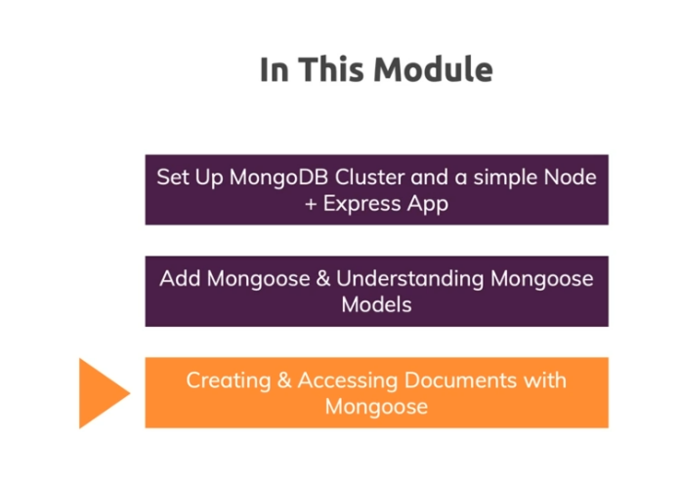

## SQL vs NoSQL

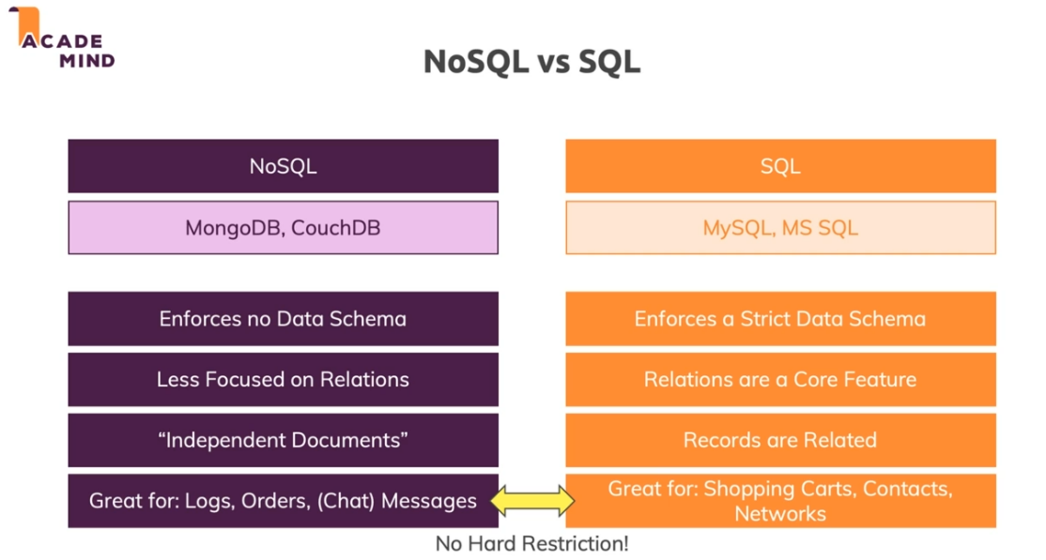

## Installation

Go to mongodb and set up a cluster with user auth and make your ip available. All can be configured in the web. Then, install mongodb with npm

npm install –save mongodb

npm install –save mongoose

If you look at section8 code, you can see some examples with how to connect with mongodb. mongo.js for instance is how to connect just using raw mongo.

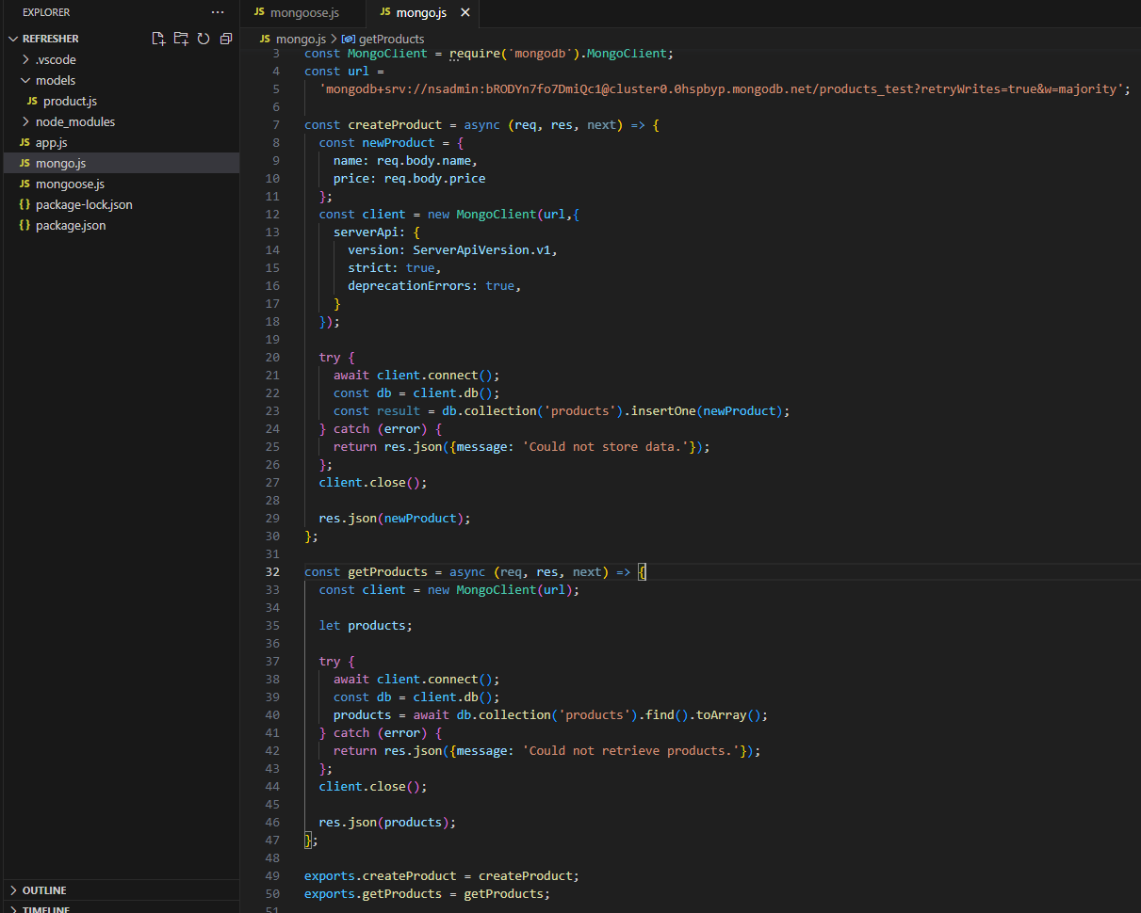

You can see the url has the username, the password, and then the db name products_test

You can see that’s a lot of code however… We have to manage the connection object, etc… We can use a third party package to make it easier for us.

## Mongoose

Mongoose helps manage a lot of the repetitive connection logic. It also allows us to define “schemas” in our code. A schema for a collection can be thought of as a blueprint. “We want our product collections to follow these specific types of fields… “ Can be defined in code. Recall though with NoSQL there is no defined structure so this doesn’t have to be the case on the db side, it just allows us to create structure on the code side. The mongoose.js can look something like this:

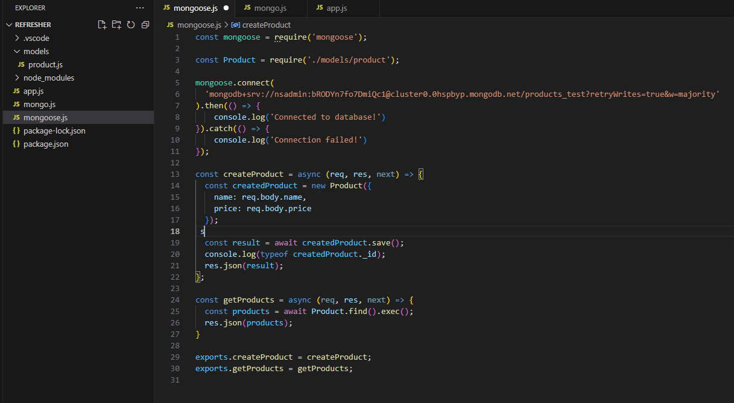

App.js:

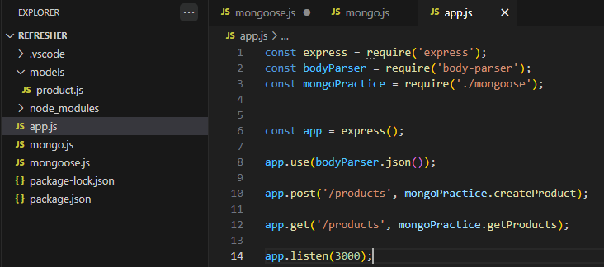

## ObjectID

The id gets added to the document, each time a new document is added. It automatically gets added. It’s a special object used for mongodb. To be able to use the id in our code, you need to turn the id into a string. Mongoose does this for us easily by doing this:

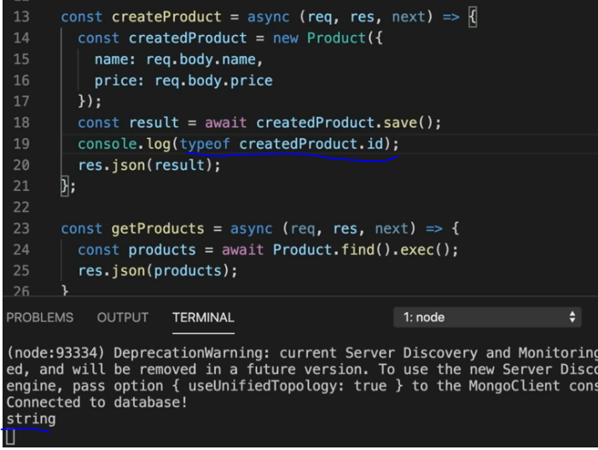

# Section9: Connecting Mongo to backend

# 